**SQL Coding Challenge - 2**

**Name : Podutur Lahari**

**Date : 08-11-2024**

**Manipulate data by using sql commands using group by and having clause**

**GROUP BY Clause :**

The GROUP BY clause groups rows that have the same values in specified columns into summary rows, like "total sales per department" or "average salary per job title." It is often used with aggregate functions (e.g., SUM(), COUNT(), AVG(), MIN(), MAX()) to perform calculations on each group.

**1. Get the total salary expense for each department (GROUP BY) :**

SELECT Department, SUM(Salary) AS TotalSalary

FROM Employees

GROUP BY Department;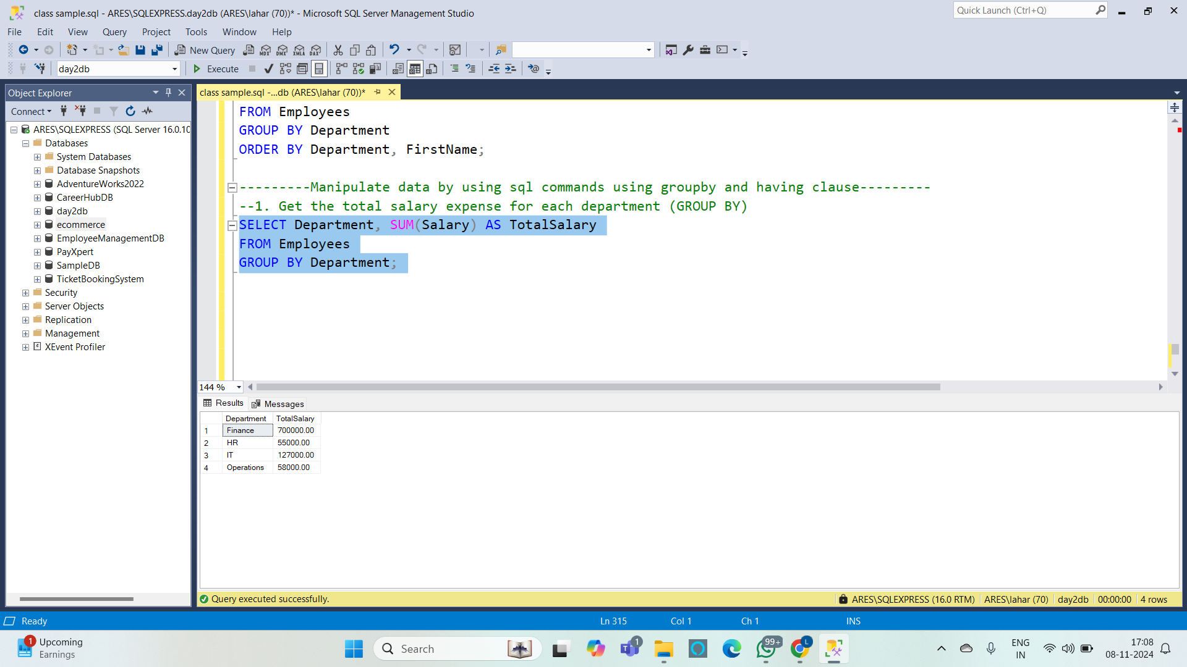

**Having Clause :**

The HAVING clause is used to filter groups based on the results of aggregate functions, similar to how the WHERE clause filters rows. However, WHERE can only be used for individual rows, not aggregated data, so HAVING is used to apply conditions to groups created by GROUP BY.

**2. List departments where the number of employees is greater than 1 (GROUP BY and HAVING) :**

**Code :**

SELECT Department, COUNT(EmployeeID) AS EmployeeCount

FROM Employees

GROUP BY Department

HAVING COUNT(EmployeeID) > 1;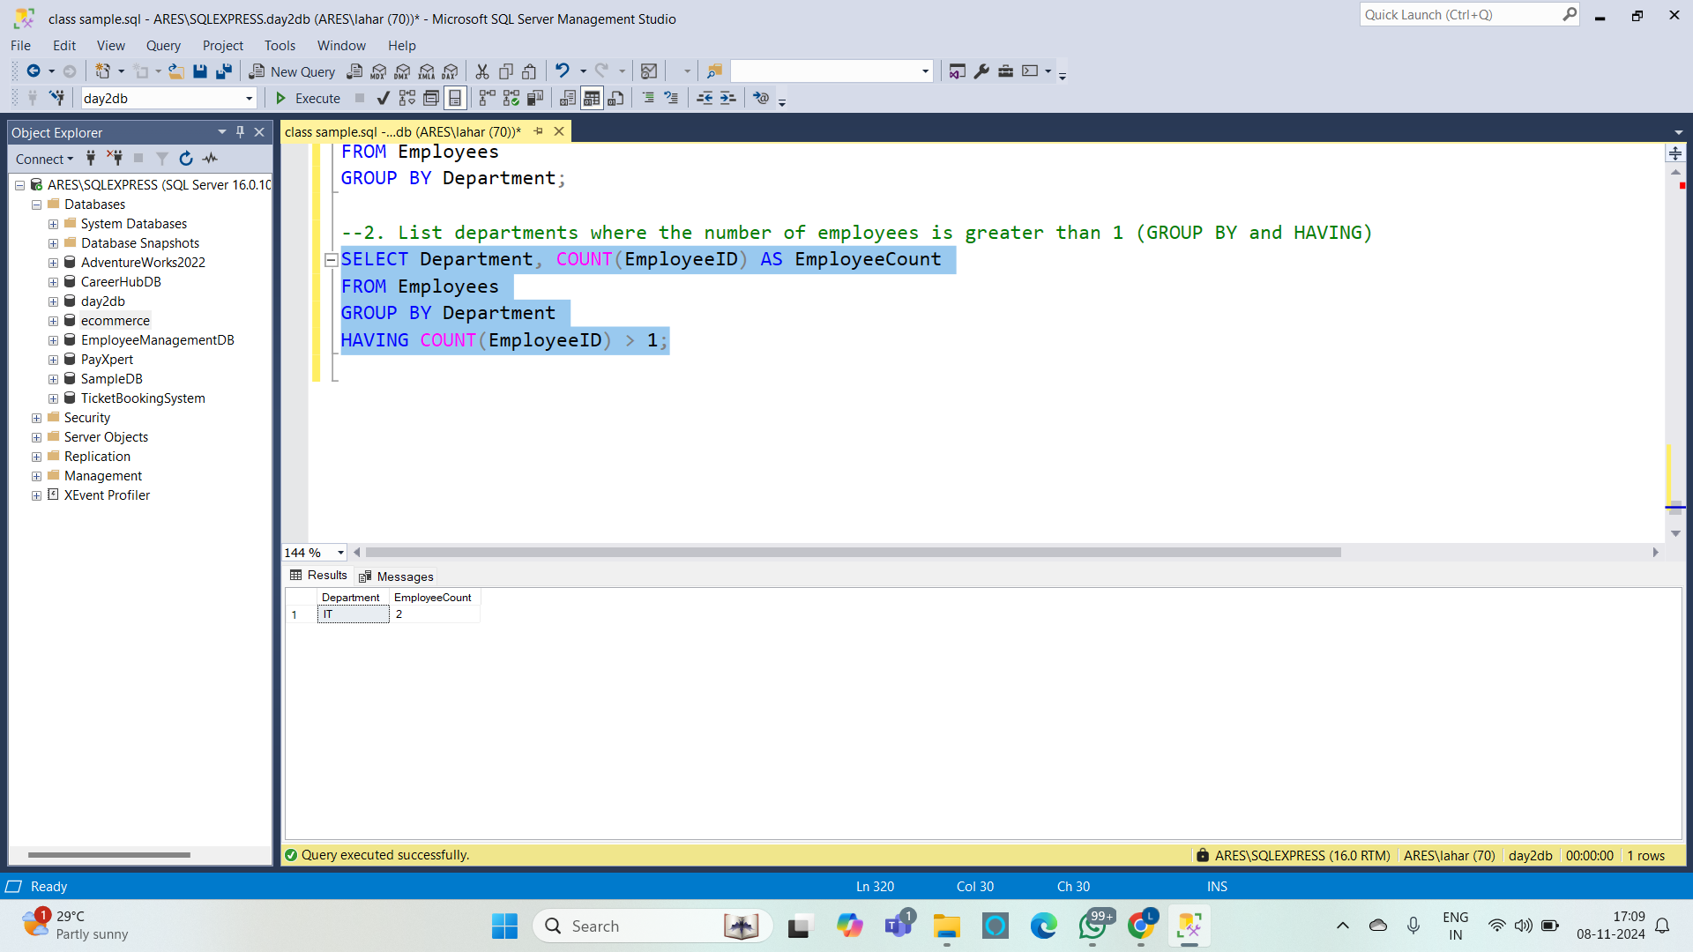

**3. Get the number of employees in each department who earn more than 55,000 (WHERE and GROUP BY) :**

**Code :**

SELECT Department, COUNT(EmployeeID) AS EmployeesAbove55K

FROM Employees

WHERE Salary > 55000

GROUP BY Department;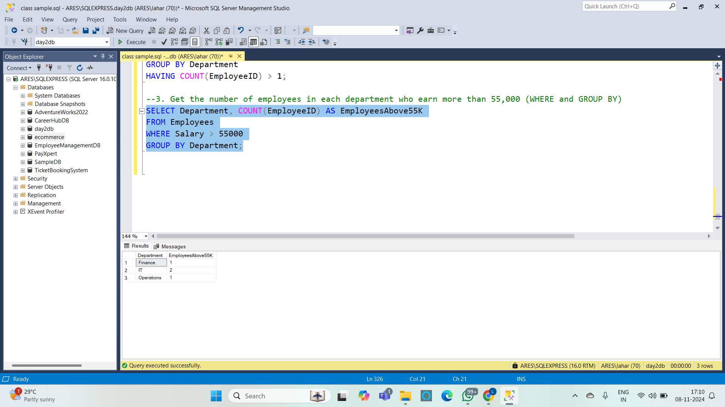

**Combining GROUP BY and HAVING with Aggregate Functions :**

You can combine GROUP BY with aggregate functions to calculate and filter data in various ways, such as finding departments with more than a specified number of employees or departments with average salaries within a certain range.

**4. Find the departments where the total salary exceeds 100,000 (GROUP BY and HAVING) :**

**Code:**

SELECT Department, SUM(Salary) AS TotalSalary

FROM Employees

GROUP BY Department

HAVING SUM(Salary) > 100000;

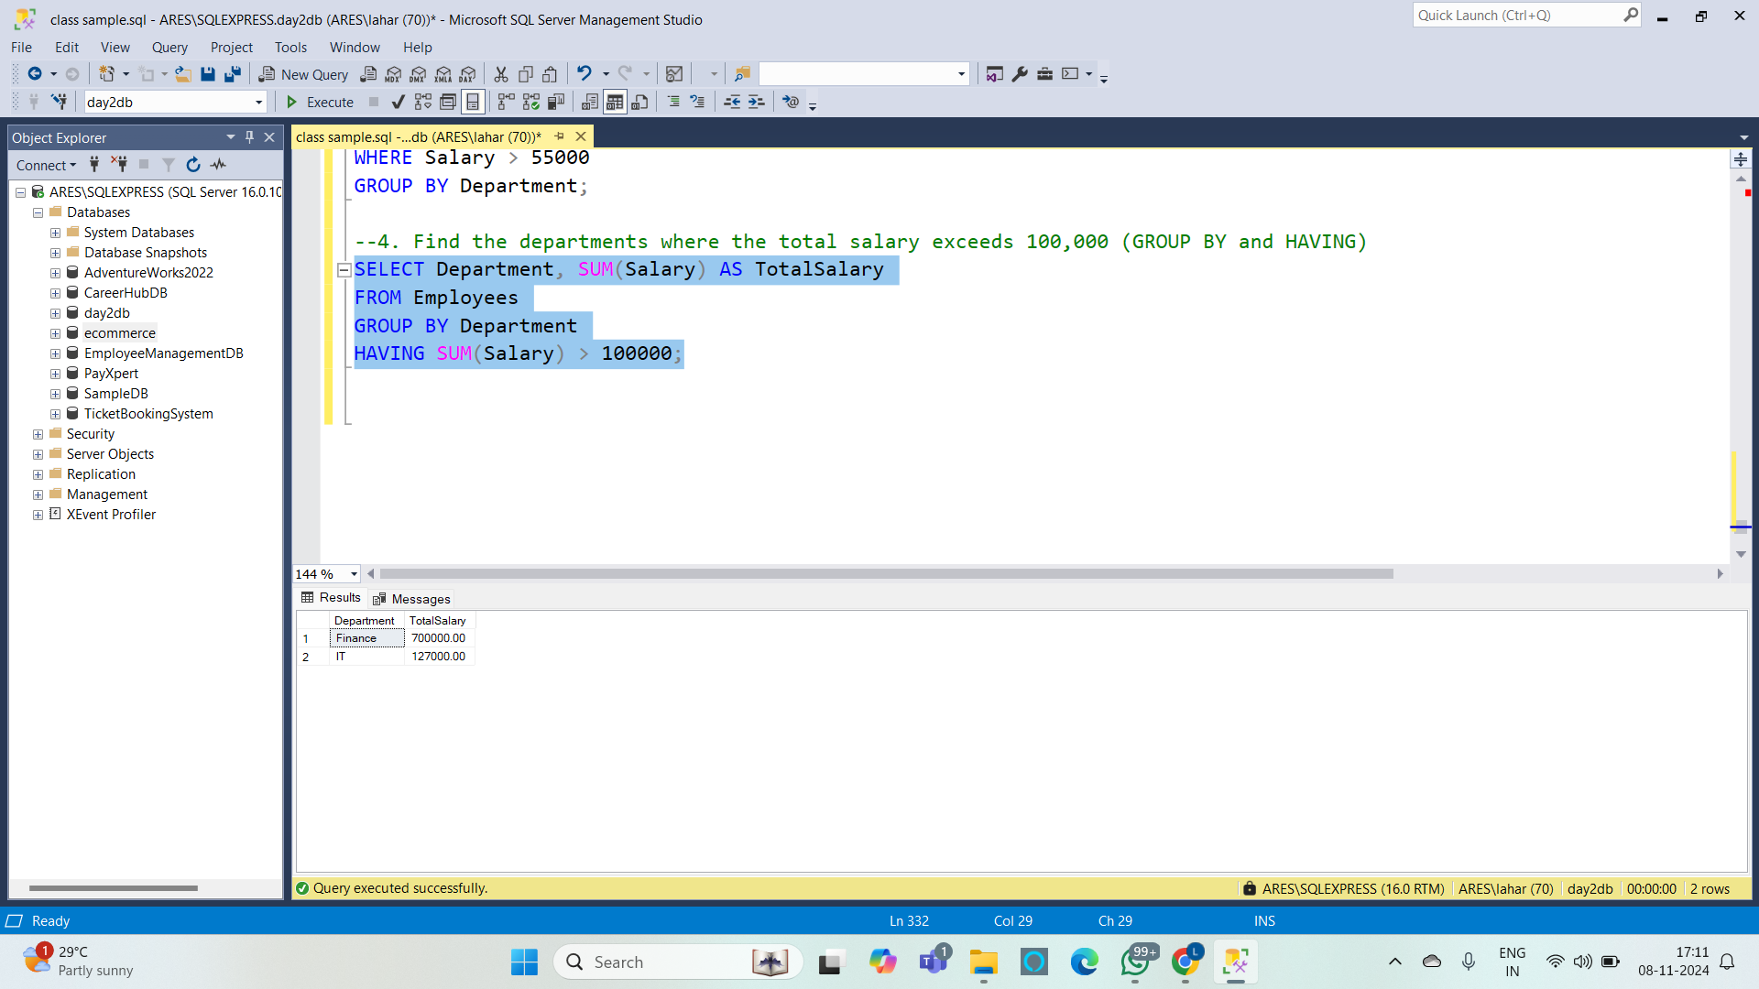

### **Differences Between WHERE and HAVING :**

* WHERE: Filters rows before they are grouped; works only with individual row data, not aggregates.
* HAVING: Filters groups after aggregation has been performed; works with aggregates.

**5. Departments where the total salary exceeds 100,000, and the average salary of employees in those departments is greater than 60,000. Only include departments with more than one employee (GROUP BY, HAVING and WHERE) :**

**Code :**

SELECT Department, SUM(Salary) AS TotalSalary, AVG(Salary) AS AverageSalary, COUNT(EmployeeID) AS EmployeeCount

FROM Employees

WHERE Salary > 50000 -- Only consider employees earning more than 50,000

GROUP BY Department

HAVING SUM(Salary) > 100000 AND AVG(Salary) > 60000 AND COUNT(EmployeeID) > 1;